1. Configure Classic Load balancer.

**Launch 2 instances with httpd configuration (in both instances)**

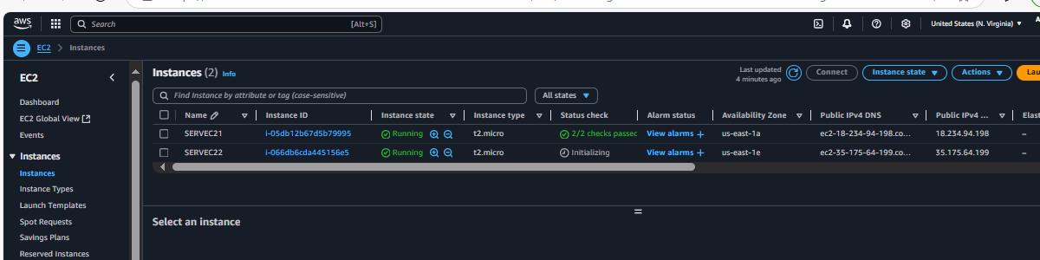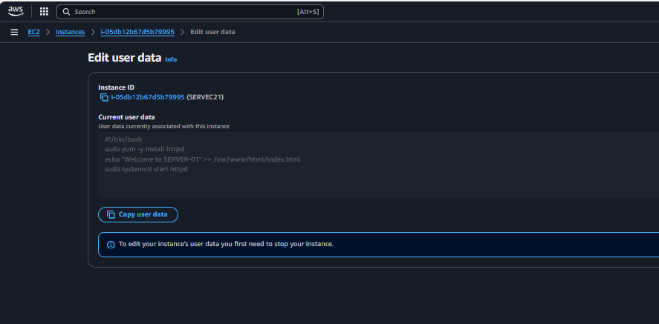

**Go to Console-🡪 EC2--🡪Load balancers--🡪Create a Classic load balancer**

**Create a load balancer and Attach both instances to the Load balancer 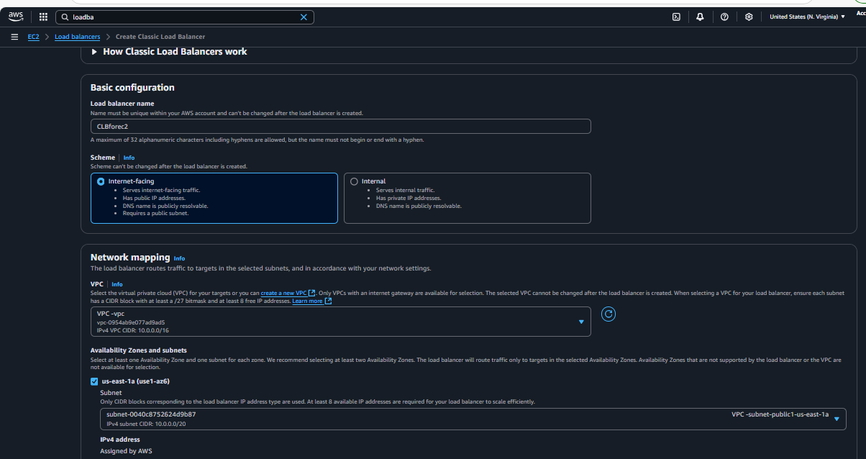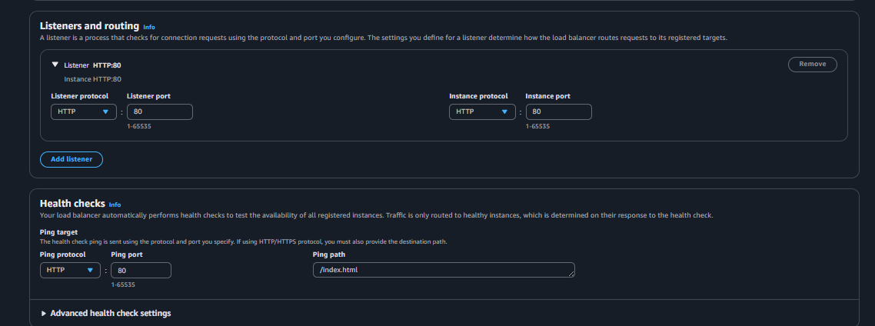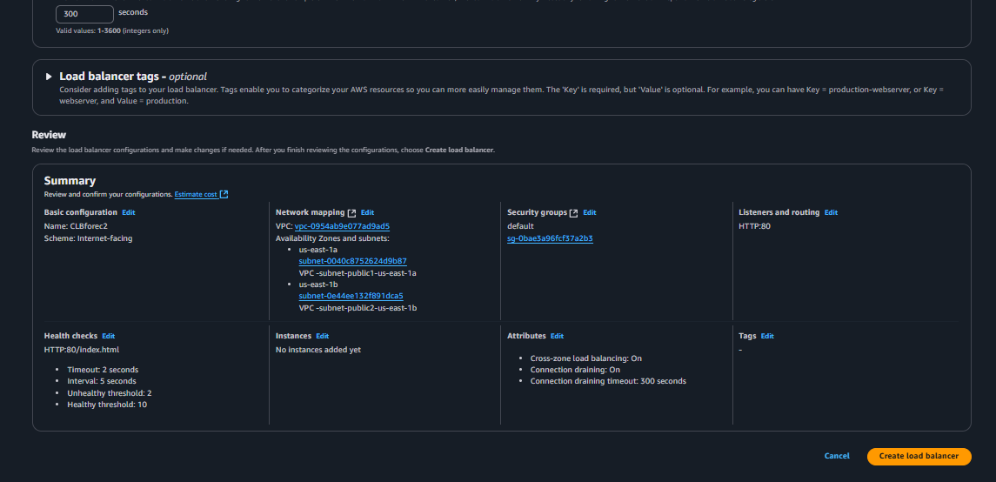select created load balancer -🡪Targrt instances-🡪 Manage instances**

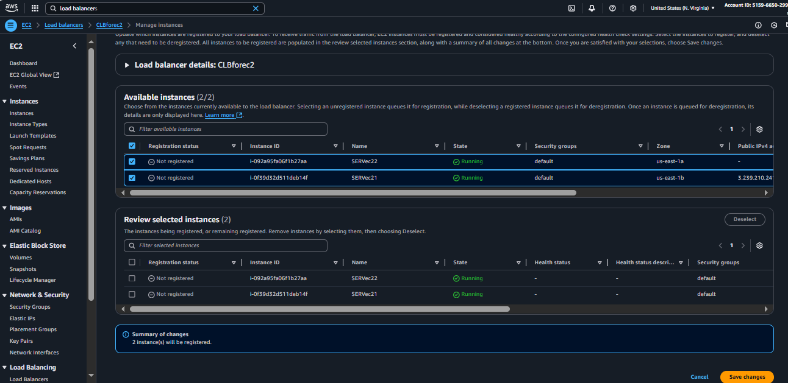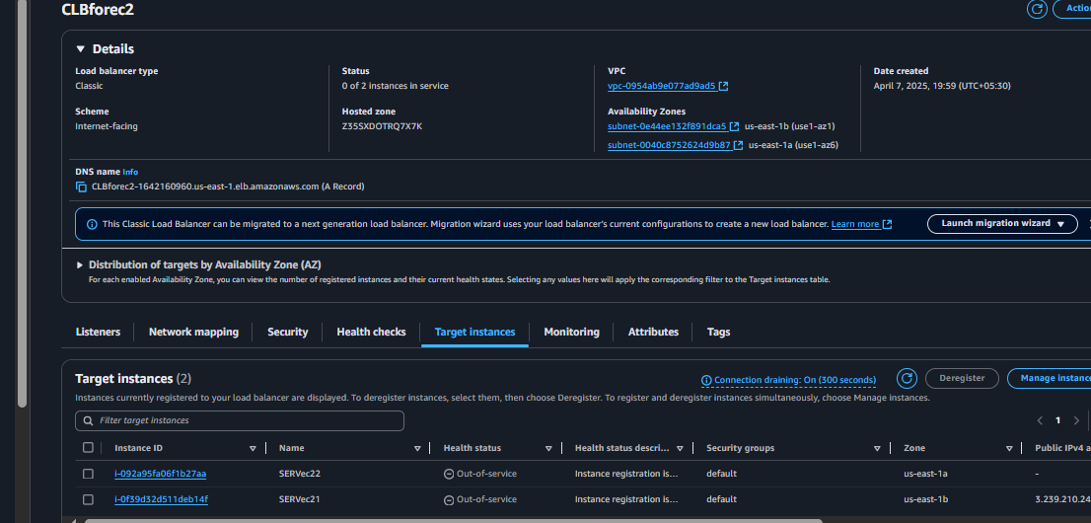

**Copy DNS name from load banker and check on browser ,you will get Server1 index page when you refresh again it will show Server 2 index page..and it continues**

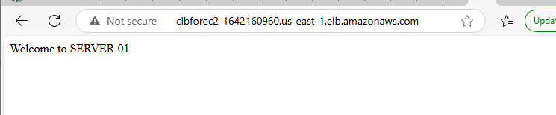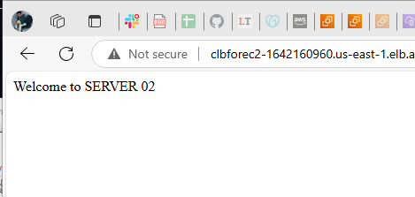

1. Configure Application Load balancer.

**First Goto Console --🡪EC2 --🡪Target Groups-🡪 Create Target group**

**Load balancers--🡪Create a Application load balancer**

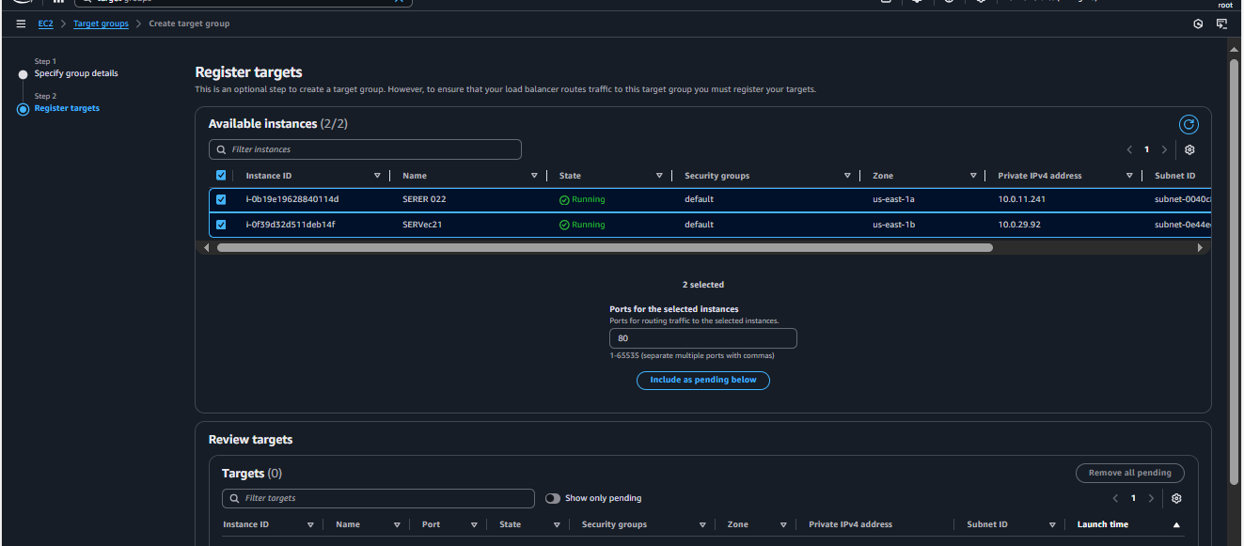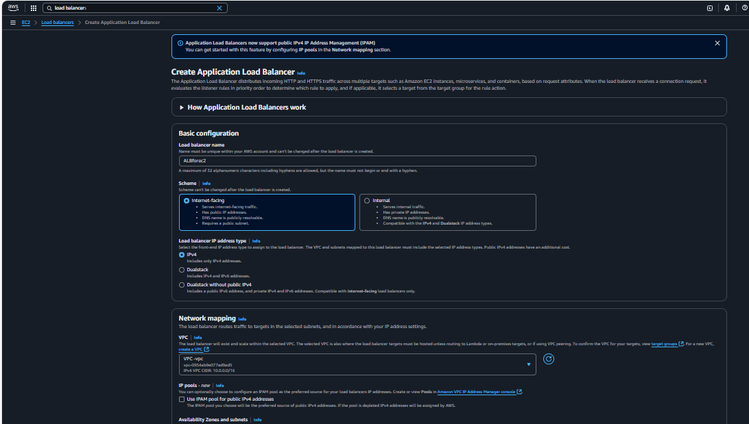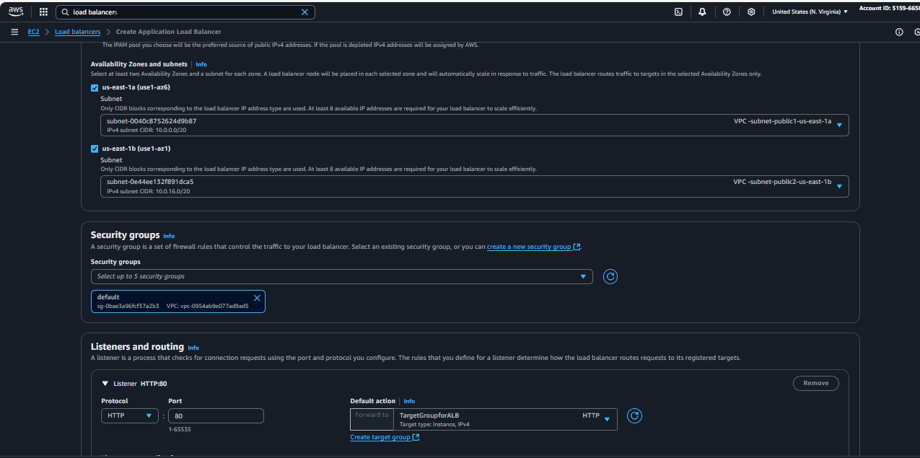

**Register instances to the Target group**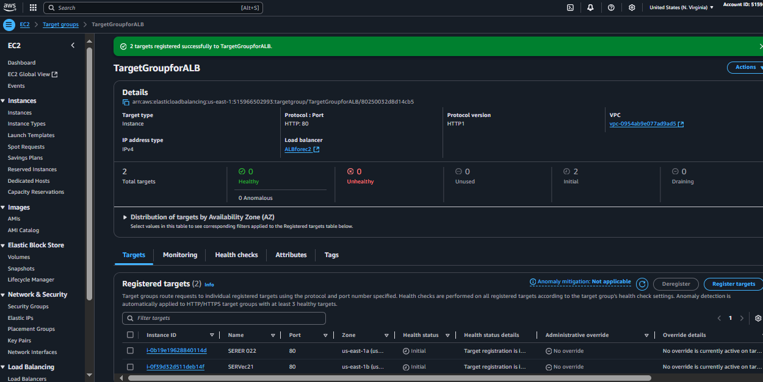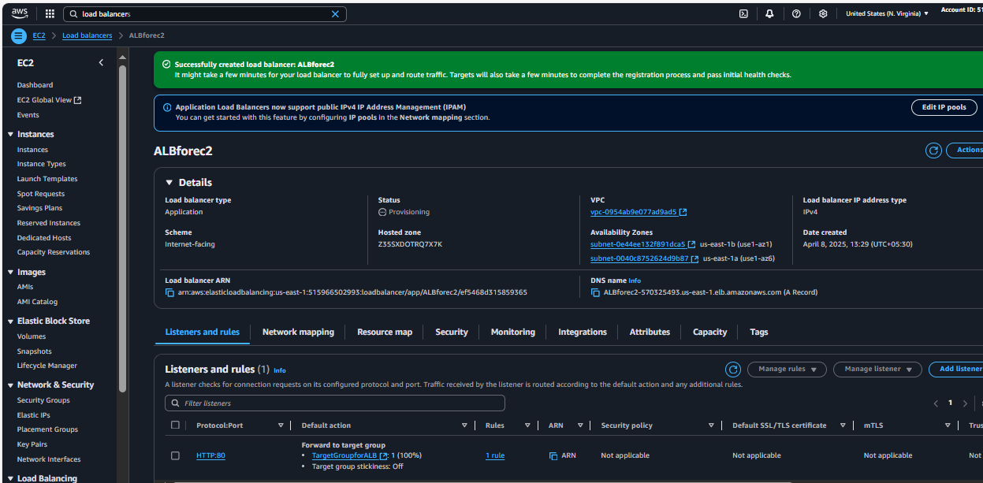

**Copy DNS name and paste on browser check its working or not**

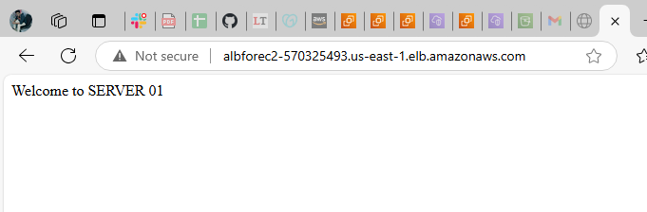

**If you refresh**

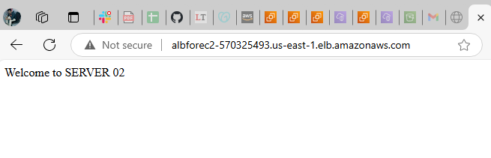

1. Configure Network Load balancer.

For configuring Network load balancer ,first we need to create 2 elastic IP’s

So that we can able to access with DNS name and Elastic IP's also

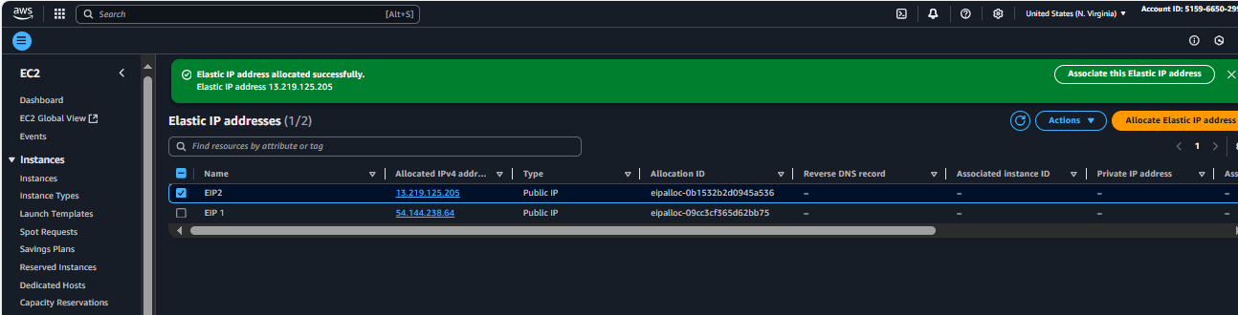

Created the network load balancer with 2 Elastic IP’s

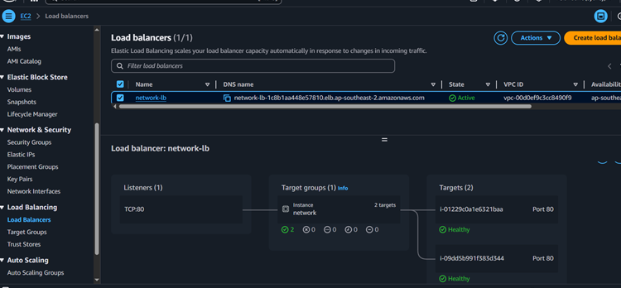Created target groups to the network load balancer

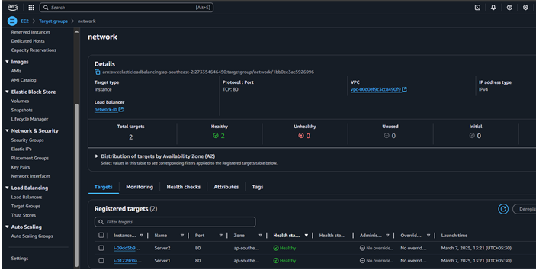

Copy the Load balancer DNS name and check on the browser

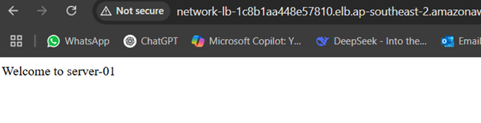

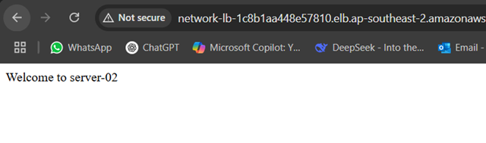

Cheeck with Elastic IP’s also 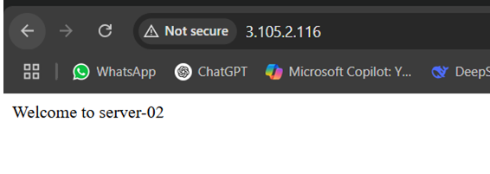 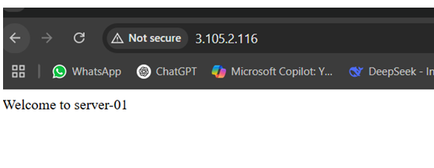

1. Attach SSL for application load balancer.

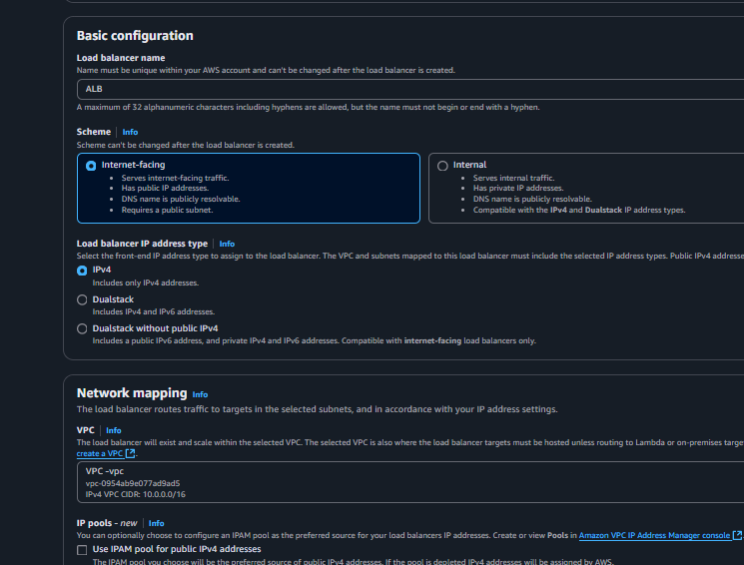 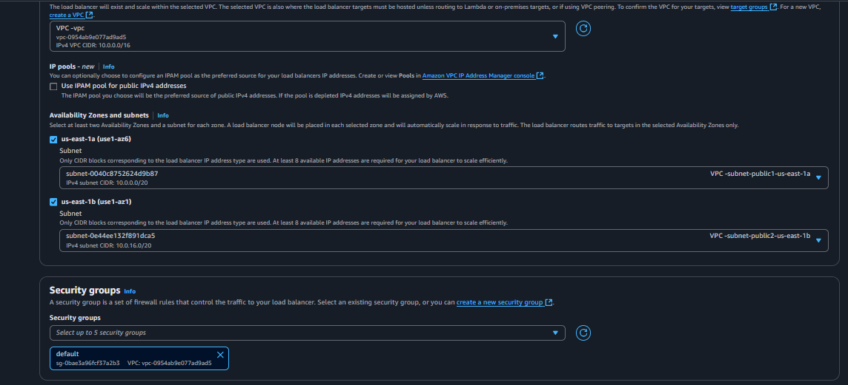 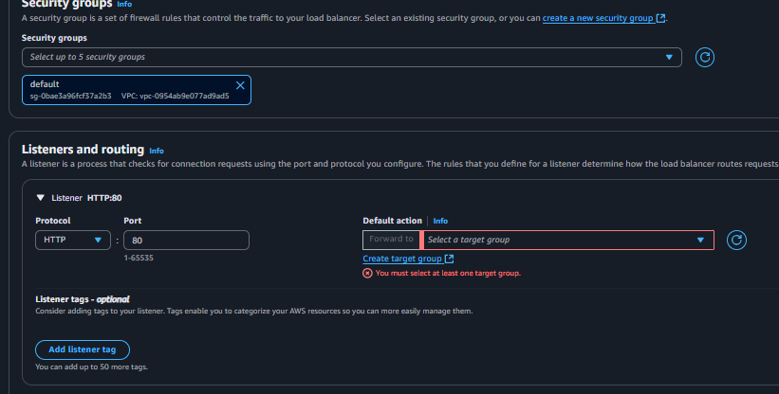 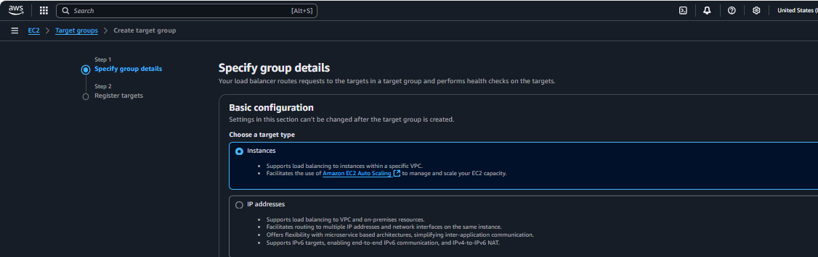 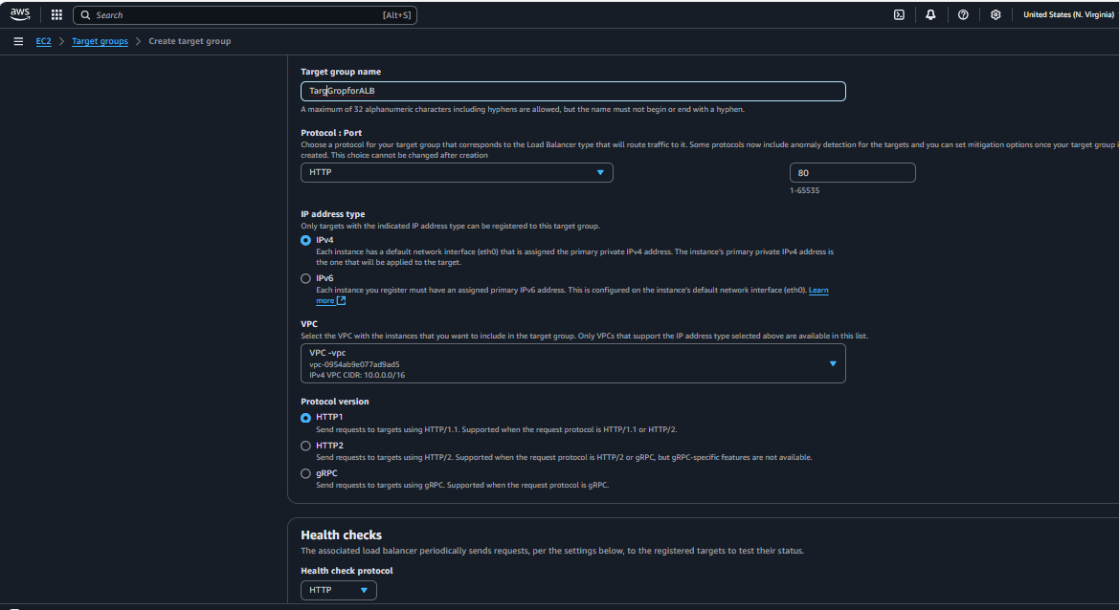

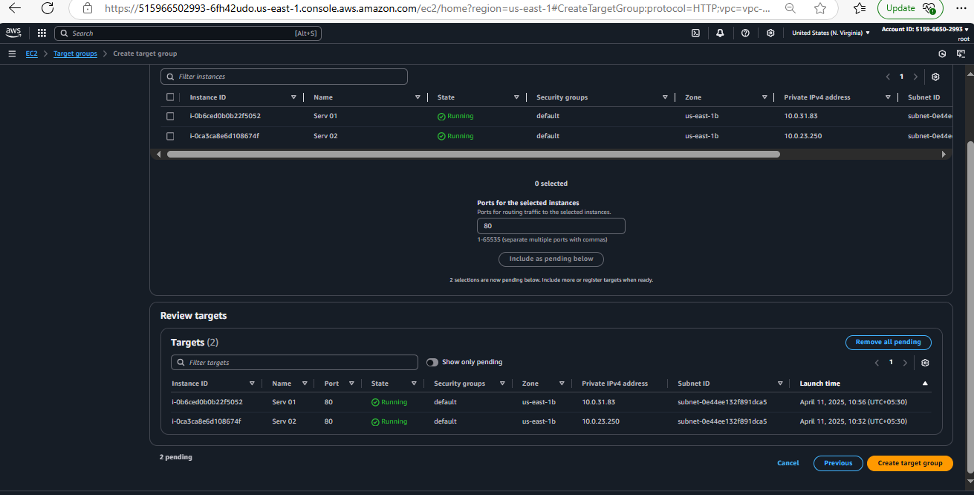

**Generate SSL certificate by adding https and at the same time create record so CNAME will get created 1 certificate issued then go to listeners attach SSL certificate and**

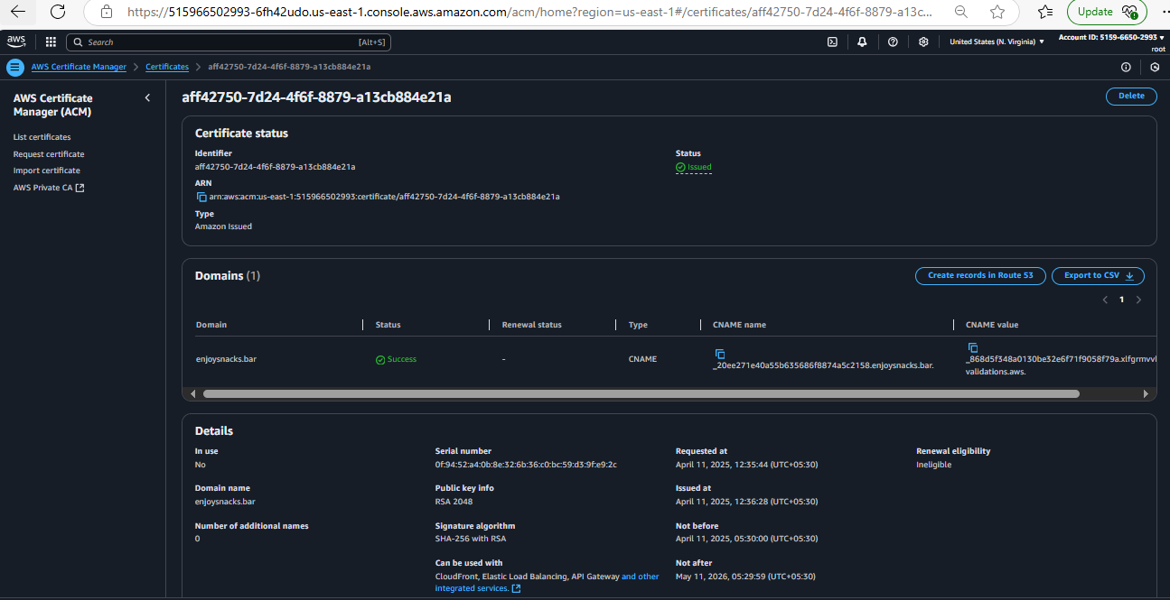

create “ A ” record in route 53 with enabling alias ALB to classic load balance option

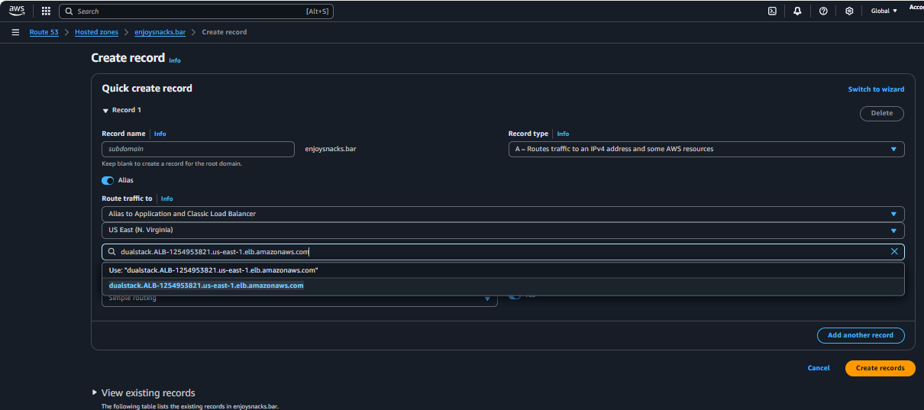 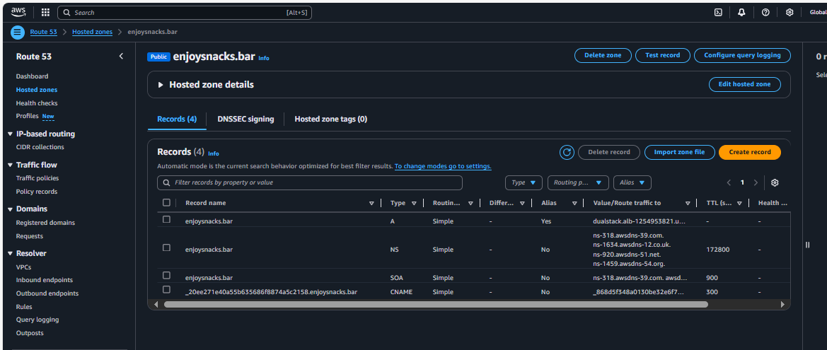 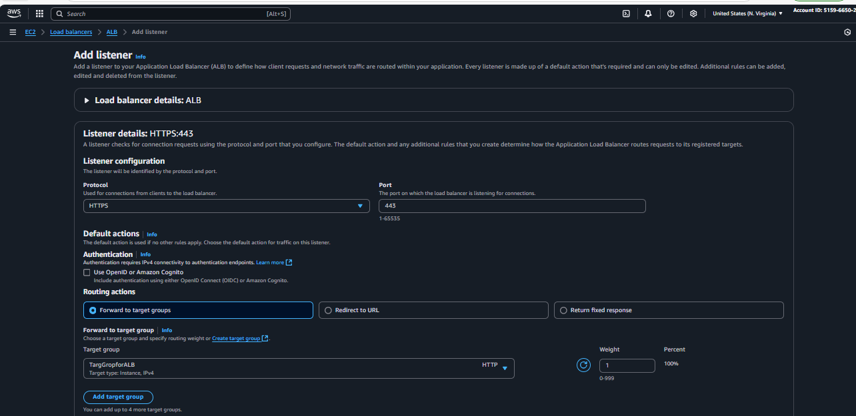 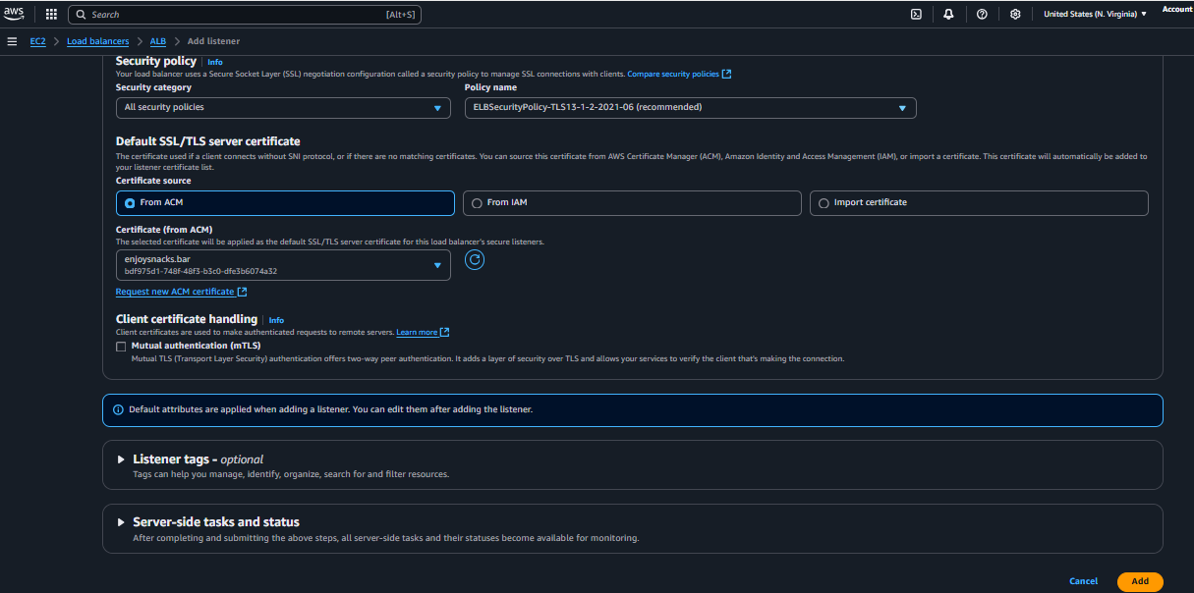 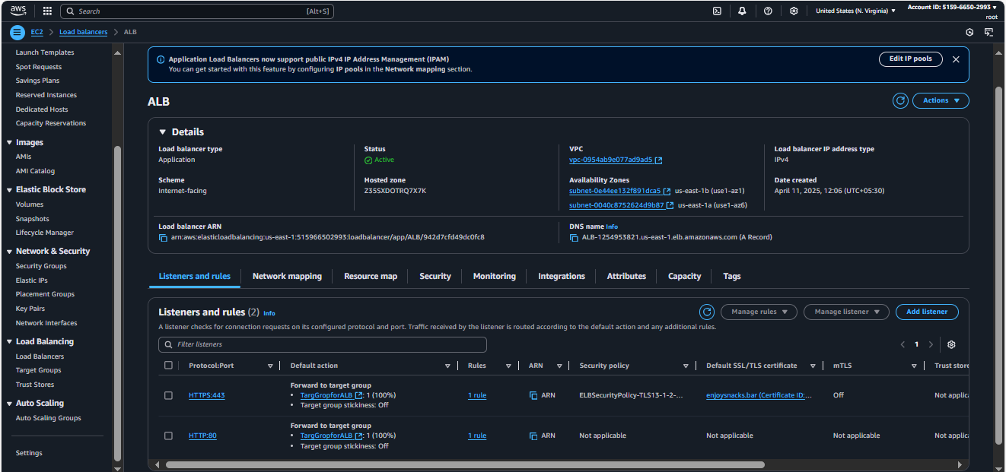 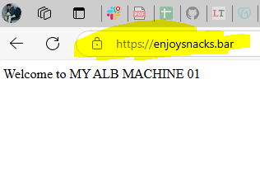 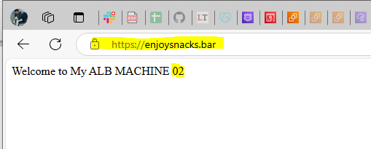

1. Map Application load balancer to R53.

**Ensure you have a registered domain in Route 53.You need to create an alias record in Route 53 that points to your ALB**.

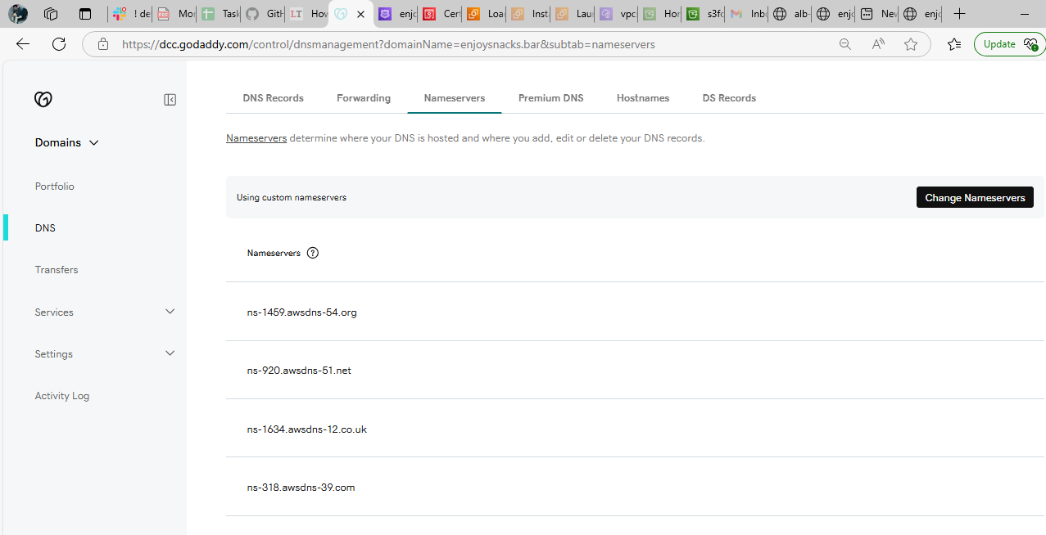

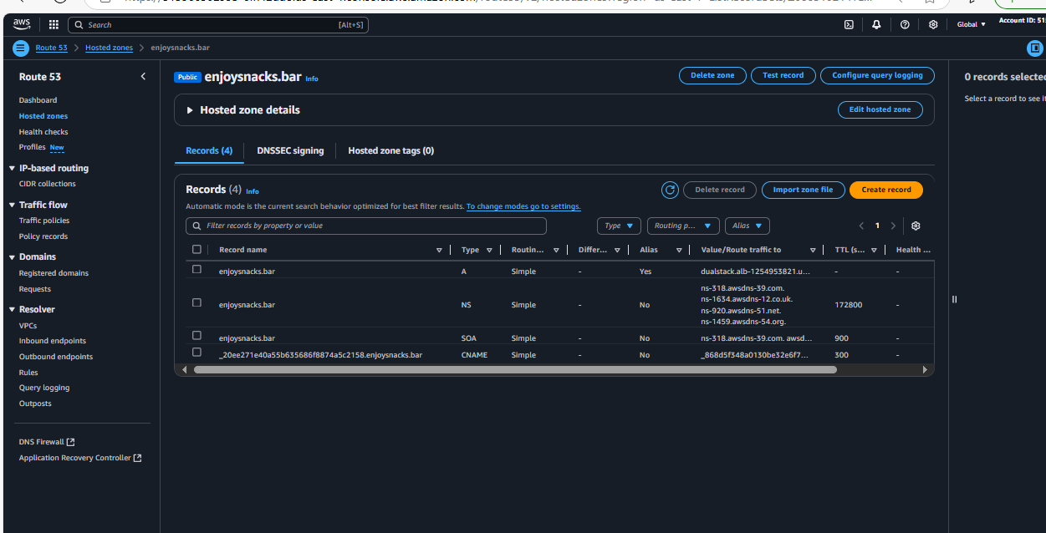

1. Push the application load balancer logs to s3.

**Goto load balancer-🡪Actions--🡪Edit load balancer attributes**

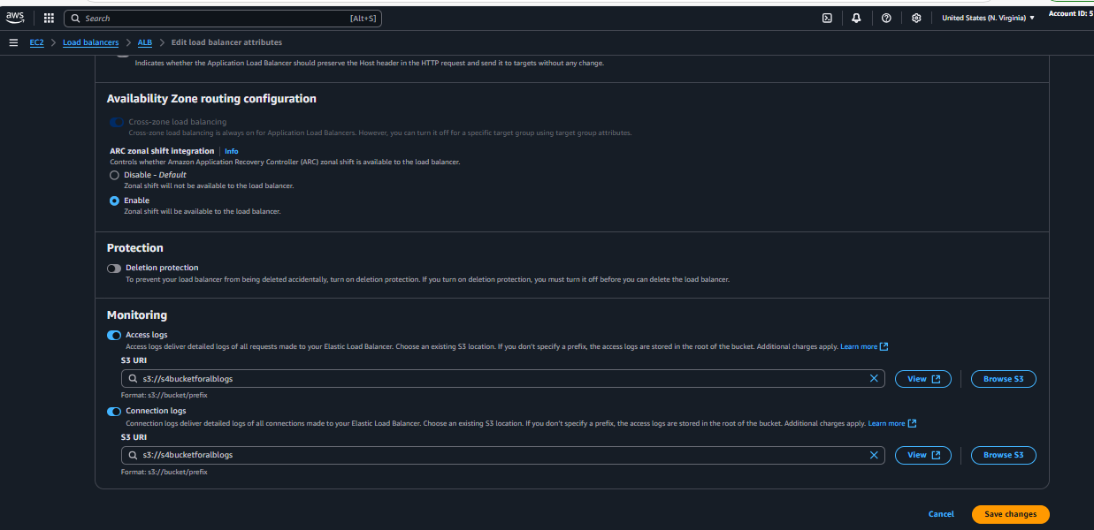

**Give bucket policy to the required bucket to store the logs**

**{**

**"Version": "2012-10-17",**

**"Statement": [**

**{**

**"Effect": "Allow",**

**"Principal": {**

**"Service": "logdelivery.elasticloadbalancing.amazonaws.com"**

**},**

**"Action": "s3:PutObject",**

**"Resource": "arn:aws:s3:::s4bucketforalblogs/AWSLogs/515966502993/*"**

**}**

**]**

**}**

